Chapter -1
Introduction

The rapid proliferation of electric vehicles (EVs) has underscored the urgent need for a robust charging infrastructure. As the global transition towards sustainable transportation accelerates, the demand for efficient and accessible EV charging solutions is paramount. This growing demand is not only driven by the increasing sales of EVs but also by supportive policies and consumer preferences favoring renewable energy sources for charging.
To meet this demand, it is essential to integrate both renewable and non-renewable power generation methods. The combination of solar energy, energy storage systems (ESS), and grid power can significantly enhance the efficiency of power supply to DC fast charging and battery swapping stations. By optimizing this integration, we can achieve substantial cost savings while ensuring a reliable energy supply that meets fluctuating charging demands.

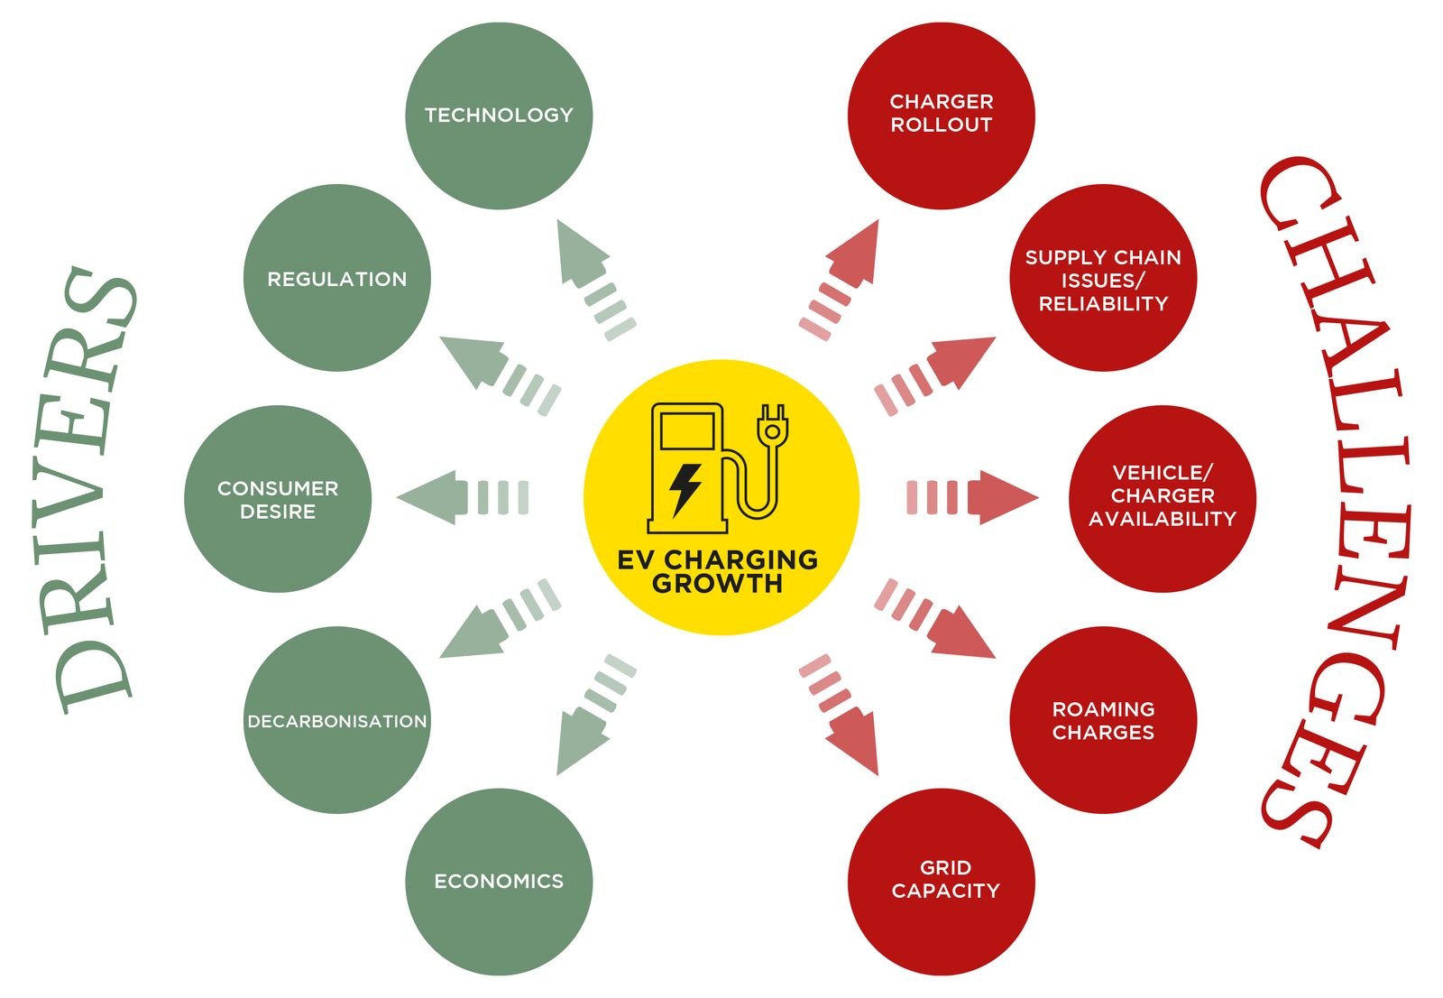

Fig 1 : EV Charging Drivers and Challenges

The proposed Internet of Things (IoT) architecture plays a critical role in this context by facilitating real-time monitoring and data collection from various sensors deployed throughout the charging infrastructure. This architecture enables remote visualization and enhances end-user connectivity, allowing users to access vital information regarding charging status, energy consumption, and availability. By leveraging predictive analytics, the system can optimize power demand management, ensuring that resources are utilized efficiently.

By utilizing real-time data monitoring, the IoT architecture allows for the optimization of power demand and battery management. This leads to improved overall efficiency in EV charging operations, as systems can dynamically adjust to changing energy needs and usage patterns. The integration of predictive analytics within the IoT framework can result in substantial cost savings. The architecture facilitates the seamless integration of renewable energy sources, such as solar power and energy storage systems (ESS), with grid power. This not only promotes sustainable practices but also enhances the reliability of power supply at charging stations.
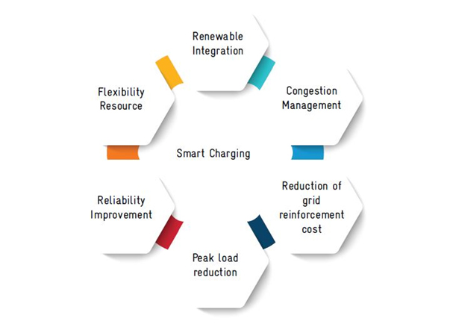
Fig 2 : Smart charging
The project proposed system enables remote access to charging status, energy consumption data, and operational metrics through a user-friendly interface. This capability enhances user engagement and allows operators to make informed decisions based on real-time insights. The IoT architecture is designed to be scalable, allowing businesses to expand their charging infrastructure in response to growing demand. This adaptability is crucial for meeting the evolving needs of consumers and the market.
The Continuous data collection from sensors provides valuable insights into customer behavior and operational performance. This information can be leveraged to identify trends, improve services, and enhance customer satisfaction. Support for Smart City Initiatives: By integrating with broader smart city frameworks, the IoT architecture contributes to the development of connected EV charging networks, promoting investments in sustainable infrastructure and enhancing urban mobility solutions.
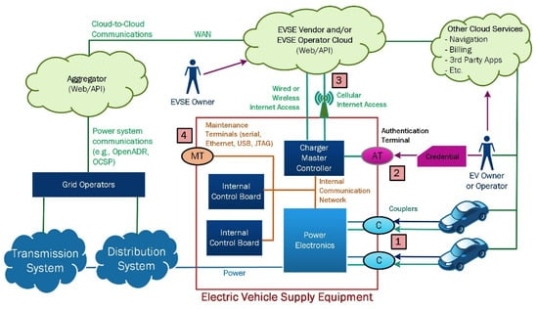
Fig 3 : Charging infra IOT integration
Predictive analytics within the IoT architecture for electric vehicle charging operations offers significant benefits that enhance both efficiency and user experience. By leveraging historical data and usage patterns, predictive analytics enable the forecasting of energy demand, allowing charging stations to proactively manage power requirements. This capability ensures that sufficient energy is available during peak usage times while minimizing costs during off-peak periods. Furthermore, predictive analytics optimize charging schedules by analyzing factors such as battery state-of-charge (SOC) and the availability of renewable energy sources. This results in more efficient charging processes, reducing energy waste and enhancing overall operational efficiency.
In addition to improving efficiency, predictive analytics contributes to substantial cost savings—potentially reducing operational expenses by up to 90%—by minimizing reliance on expensive grid power during peak hours and maximizing the use of renewable energy. It also enhances maintenance and reliability by identifying potential equipment failures before they occur, allowing for proactive maintenance scheduling that reduces downtime. User engagement is another critical advantage; real-time information about charging status and availability fosters better customer experience, leading to increased satisfaction and loyalty.
The scalability and adaptability provided by predictive analytics are essential as EV adoption continues to grow. This flexibility allows charging infrastructure to expand without compromising service quality. Ultimately, the insights gained from predictive analytics empower operators to make informed decisions regarding pricing strategies, resource allocation, and infrastructure investments, creating a more sustainable and efficient EV charging ecosystem.

1.1 Background and Motivation
The rapid adoption of electric vehicles (EVs) worldwide has underscored the urgent need for efficient, scalable, and sustainable charging infrastructure. With global EV sales surpassing 10 million units in 2022 (IEA, 2023), existing charging networks face critical challenges, including grid instability, high operational costs, and reliance on non-renewable energy sources.
Traditional charging stations often struggle with long charging times, limited interoperability, and inefficient power management, leading to suboptimal user experiences and increased strain on electrical grids. To address these challenges, this research proposes an IoT-based architecture that integrates solar energy, battery storage systems (ESS), and grid power through intelligent control mechanisms. By leveraging real-time data analytics, predictive algorithms, and automated energy distribution, this system aims to reduce operational costs by 80%, enhance charging efficiency, and promote renewable energy utilization in EV infrastructure.

1.2 Current State of EV Charging Technology
Modern EV charging systems primarily consist of Level 1 (AC slow charging), Level 2 (AC fast charging), and DC fast charging stations, each with distinct power requirements and limitations. While DC fast chargers (50–350 kW) significantly reduce charging times, they impose high demand on local grids, leading to voltage fluctuations and peak load challenges. Recent advancements, such as Vehicle-to-Grid (V2G) technology and smart charging algorithms, have improved grid interaction but lack seamless integration with renewable energy sources. Furthermore, existing systems often operate in isolation, missing opportunities for dynamic load balancing, battery health optimization, and cost-effective energy sourcing. This research bridges these gaps by introducing a unified IoT architecture that coordinates multiple power sources while ensuring reliability and scalability.

In addition to conventional plug-in charging, battery swapping stations (BSS) present a revolutionary approach to EV energy replenishment. Unlike traditional charging, which requires 30+ minutes for DC fast charging, swapping enables full battery replacement in under 5 minutes, significantly reducing downtime for commercial fleets (e.g., taxis, delivery vehicles). This method involves pre-charged modular batteries stored at centralized stations, allowing users to exchange depleted batteries for fully charged ones seamlessly.

1.3 Challenges in Renewable Energy Integration
Incorporating solar power and ESS into EV charging networks introduces technical complexities, including intermittent energy generation, storage inefficiencies, and synchronization issues at the Point of Common Coupling (PCC). Solar energy, while sustainable, suffers from variability due to weather conditions, necessitating real-time MPPT (Maximum Power Point Tracking) algorithms to maximize efficiency. Similarly, battery storage systems require advanced State of Charge (SOC) and State of Health (SOH) monitoring to prevent degradation. This research addresses these challenges through a layered IoT framework that employs predictive analytics for energy forecasting, adaptive PCC control for seamless source switching, and cloud-based monitoring to optimize performance under dynamic conditions.
1.4 Role of IoT in Smart Charging Systems
The Internet of Things (IoT) has revolutionized energy management by enabling real-time data acquisition, remote monitoring, and automated decision-making. In EV charging, IoT facilitates smart grid integration, demand-response strategies, and user-centric services such as mobile app-based charging scheduling and payment processing.
This research extends IoT applications by developing a five-layer architecture comprising:
- Sensor Layer (voltage, current, temperature monitoring)
- Microcontroller & Data Acquisition Layer (BMS, real-time processing)
- Communication Layer (MQTT, IoT gateways)
- Cloud & Data Storage Layer (AWS S3, predictive analytics)
- User Interface Layer (dashboard visualization, alerts)
This structure ensures end-to-end visibility, adaptive energy management, and scalability for future expansions.

1.5 Research Objectives and Contributions
This study aims to design, simulate, and validate an IoT-driven battery charging management system that optimizes power distribution among solar, ESS, and grid sources. Key contributions include:
- A novel PCC automation algorithm for dynamic energy switching
- Solar MPPT optimization to enhance renewable energy harvesting
- Battery health-aware charging protocols to extend lifespan
- AWS cloud integration for real-time analytics and alerts
- Cost-benefit analysis demonstrates 80% operational savings

1.6 Our Contribution

This study presents an IoT-optimized battery charging management system with key innovations:
- A dynamic power allocation algorithm enables automatic switching between solar, ESS, and grid power at the PCC, achieving 80% grid independence during daylight through real-time energy availability monitoring, cost optimization, and load forecasting.
- A customized MPPT algorithm enhances solar utilization with 70% partial-shading efficiency while protecting PV panels through adaptive voltage control.
- For battery swapping stations, we developed a SOC balancing algorithm for uniform charge distribution, priority-based allocation logic, thermal management protocols (limiting charging at >45°C), and MATLAB-optimized scheduling for 40% off-peak cost reduction.
- The IoT architecture integrates five layers: multi-parameter sensors, edge-based BMS analytics, MQTT/HTTP communication, AWS cloud services, and user interfaces.
- Predictive maintenance employs machine learning (92% SOH prediction accuracy) with fault detection and automated fire suppression.
- Validation via MATLAB simulations shows 40% faster charging, Node-RED prototypes with 30+ sensors, and collectively advancing sustainable EV infrastructure through renewable energy optimization and battery lifespan extension.

1.7 Thesis Organization

This research document is systematically organized to present a comprehensive study on the design of IoT architecture for battery charging management. The thesis begins with
Chapter 1 (Introduction), which establishes research background, problem statement, objectives, and key contributions, emphasizing the integration of solar energy, energy storage systems (ESS), grid power, and battery swapping technology.
Chapter 2 details the automated power integration system at the Point of Common Coupling (PCC), which optimally combines solar, battery storage, and grid power to reduce grid dependency by 80% during daylight hours.
Chapter 3 (Literature Review) critically examines existing EV charging solutions and IoT frameworks, identifying gaps in renewable energy integration and PCC automation.
Chapter 4 (Proposed System Methodology) details the five-layer IoT architecture, from sensor-level data acquisition to cloud-based analytics, and explains the core algorithms for dynamic power allocation, solar MPPT optimization, and battery swapping station management.
Chapter 5 (Simulation Tools and Implementation) describes the MATLAB/Simulink models used for simulating hybrid power flow and battery degradation, along with Node-RED prototyping for real-time monitoring.
Chapter 6 (Results and Discussion) presents empirical findings, including 80% grid independence during daylight, 40% faster charging in simulations, and a 30% improvement in battery lifespan.
Chapter 7 (Conclusion and Future Work) summarizes the research outcomes and suggests advancements such as energy source integration and with some operation conditions and IOT Architecture to optimize the operational cost and energy.
Chapter 8 (References) This chapter compiles authoritative sources that informed the technical and practical foundations of this research from IEEE Papers and Industry Case Studies & Technical Report.
Chapter 9 (Publications) The project patent application has been successfully published Indian patent office, making its details publicly available.

